

**GOVERNMENT COLLEGE OF ENGINEERING BARGUR**

**(AUTONOMOUS)**

**BIG DATA ANALYSIS WITH IBM CLOUD DATABASES**

**TEAM MEMBERS**

Indhupriya S.

Kaviyapriya K.

Lavanya T.

Pratibha T.

Samisha V.

**PROBLEM STATEMENT:**

“Today's organizations generate vast amounts of data from various sources, including customer interactions, sensors, and social media. Analyzing this data is crucial for making informed business decisions, but traditional data analysis tools are often inadequate to handle the volume, variety, and velocity of big data. Therefore, the problem at hand is to develop a robust big data analysis solution that can efficiently process and extract valuable insights from large and complex datasets, enabling organizations to gain a competitive edge, improve decision-making, and drive innovation."

**ABSTRACT:**

In the context of big data, abstraction refers to simplifying and managing the complexity of large and diverse datasets by concealing unnecessary details while highlighting the essential elements. This process involves:

Data Modeling: Creating models that represent the data at different levels of abstraction, allowing users to focus on specific aspects without dealing with the entirety of the dataset.

Aggregation: Summarizing and condensing large volumes of data into more manageable and understandable forms, such as summary statistics or aggregated views.

Data Structures and Algorithms: Employing efficient data structures

algorithms to handle, access, and process large datasets while

abstracting the underlying complexities from the end-user.

Data Virtualization: Offering a unified view of distributed and varied data sources, abstracting the complexity of the data storage and allowing users to access data without understanding its detailed physical location.

Query Optimization: Abstracting the optimization process in querying data by using high-level query languages and optimizing the execution of queries across distributed or massive datasets.

Overall, abstraction in big data helps users focus on the essential aspects of the data relevant to their tasks or analyses, while hiding the intricacies that could overwhelm or complicate the understanding and processing of such vast amounts of information

**BIG DATA ANALYSIS:**

Big data is useful to invent novel patterns and outcomes which the user didn’t observe ever and it is one of the stimulating subjects. In recent days, big data is used to develop the users’ or the learner’s career, and analysing the big data project ideas are useful for the big data learner. The deployment of big data analysis is to develop the analytic techniques in contradiction of several data such as semi-structured, unstructured, and structured data which belongs to various resources and the size differ from terabytes to zettabytes. In the following, our research professionals have highlighted the utilities of big data analysis projects and it is beneficial for the research scholars.

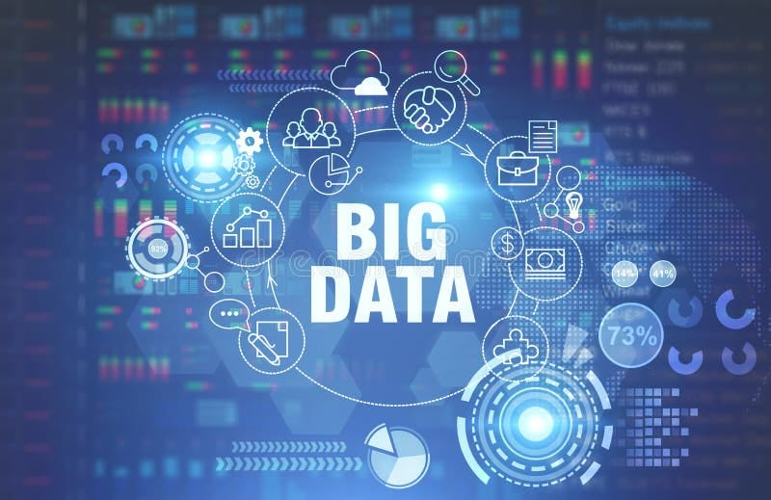

### **HOW CAN USE BIG DATA?**

There are many methods for image recognition, including machine learning and deep learning techniques. The technique you use depends on the application but, in general, the more complex the problem, the more likely you will want to explore deep learning techniques.

Use All the Data

To find the dangerous perceptions in the aggregated data, we have to use the data expensively. The data which is gathered from the experience of the customers are used to develop the product brands

Operate in Real-Time

We have to implement the business in real-time and it leads to understanding the experience of the users with the real-time data. In the end, we come to know that where we have to improve the performance and to increase the productivity with the best user experience

Capture All the Information

Through collecting data from the users is helpful to get detailed knowledge about the users and their needs. So, it is useful to improve the production of the brand

Be Agile

We have to be agile in the novel technologies because the requirements of the users are stable. They will renovate to the trending technology, so our technology must meet the users requirements

Be Platform Neutral

The users may use various devices for the accessing process, so we have to collect the relevant data from thedevices such as laptops, tablets, smartphones, etc.

**SIX BIG DATA ANALYSIS TECHNIQUES**

Machine Learning:

Machine learning is one of the significant fields in artificial intelligence and

it is deployed in the process of data analysis

Statistics:

It is used to interpret, organize, and gathering data throughexperiments and

surveys

Data Fusion and Data Integration:

The combination of a group of techniques deployed in the process of

Inegration and data analysis over the different sources and solutions. The

perceptions made here are accurate and effective to improve the single-source

here are accurate and effective to improve the single-source data

Natural Language Processing:

The data analyzing tool might use some algorithm to analyze the human

language and it is the amplitude of artificial intelligence, computer science,etc

Data Mining:

In database management, a set of methods such as machine learning and

statistics are used to extract the data mining and data analytics patterns

through the large data sets

A / B Testing:

The methods of data analysis are used to relate the several rest groups

and control groups to determine the alterations to develop the objective

variable. The big data analysis is accomplished through the alliterations in

the size.

Other Big Data Analysis Techniques:

Above we have discussed the techniques used in the process of big data

analysis projects in detail. In addition, our experts have listed the other

techniques in the big data analysis.

Connotations of Learning the Rules

Spatial Analysis

Network Analysis

Analytical Modeling

The technologies used to analyze, regulate and process are dissimilar from

others and it is also an expensive field.

**LITRERATURE & REVIEW**

A literature review on big data analysis typically encompasses studies, articles, and papers on various aspects of big data, such as its storage, processing, analysis techniques, tools, applications, and implications. It covers a range of topics like:

1. Big Data Fundamentals: Understanding the concept, characteristics, and challenges of big data.

2. Big Data Technologies: Reviewing various technologies like Hadoop, Spark, NoSQL databases, etc., used in big data analysis.

3. Data Mining and Machine Learning: Exploring techniques for data mining, predictive modeling, and machine learning applied to big data.

4. Data Processing and Analytics Tools: Analyzing tools used for processing and analyzing large datasets.

5. Big Data in Specific Industries: Studying the application of big data in industries like healthcare, finance, marketing, etc.

6. Privacy and Ethical Implications: Investigating the ethical considerations and privacy issues related to big data analysis.

To perform a comprehensive literature review, one needs to search academic databases (like PubMed, IEEE Xplore, Google Scholar, etc.) using specific keywords related to big data analysis and then critically evaluate and synthesize the findings from various sources.

**DATA COLLECTION:**

Data collection is a fundamental step in any big data analysis project. It involves gathering, storing, and preparing the data for analysis. Here's a guide on how to describe the data collection process in your project.

Data Sources:

Specify the sources of data you have used. This can include databases, external APIs, sensor data, surveys, or any other relevant sources.

Data Acquisition:

Explain how you obtained the data. Did you use web scraping, purchase a dataset, collect data through surveys, or retrieve it from internal company records?

Data Volume:

Provide information about the volume of data you collected. How large is the dataset in terms of records, rows, and size in bytes or terabytes?

Data Types:

Describe the types of data you collected, such as structured data (e.g., CSV files, SQL databases), unstructured data (e.g., text, images), or semi-structured data (e.g., JSON or XML).

Data Cleaning:

Mention any data preprocessing and cleaning steps you performed. This could involve handling missing values, removing duplicates, or transforming data into a usable format.

Data Privacy and Ethics:

Address any ethical considerations related to data collection, especially if personal or sensitive data was involved. Explain how you ensured data privacy and complied with relevant regulations.

Data Storage:

Detail where and how you stored the collected data. This could be in a local database, a cloud-based storage solution, or distributed storage systems.

Data Update Frequency:

Indicate whether the data is static or if it is updated regularly. If it's the latter, describe the update frequency.

Version Control: Mention if you implemented any version control for your dataset, especially if updates or changes occur over time.

Here's an example of how you might describe the data collection process for a project analyzing online user behavior on a website:

The dataset consists of over 10 million records of user interactions and 500,000 customer profiles, with a total data size of approximately 2 terabytes.

Sampling Method (if applicable):

A random sample of 1% of the website log data was used for initial exploratory analysis due to its large size, with the full dataset utilized for predictive modeling.

**DATA ANALYSIS:**

Data analysis for big data involves the systematic examination of vast and diverse datasets to extract valuable insights and make informed decisions. It typically includes:

Preprocessing and Cleaning: Managing, cleansing, and preparing the data by addressing missing values, inconsistencies, and errors.

Exploratory Data Analysis (EDA): Conducting initial investigations to summarize the main characteristics of the dataset, often involving visual methods.

Data Mining and Machine Learning: Applying various algorithms and statistical techniques to identify patterns, trends, correlations, and anomalies within the data.

Predictive Analysis: Using historical data to make predictions or forecast future trends and behaviors.

Text and Sentiment Analysis: Analyzing textual data to derive insights such as sentiment analysis, topic modeling, and natural language processing.

Real-time Analytics: Performing analyses on streaming data for immediate decision-making.

Visualization and Reporting: Presenting findings through visual representations like graphs, charts, and reports for better comprehension and decision-making.

The process involves a combination of technical skills, domain expertise, and tools (e.g., Python, R, SQL, Hadoop, Spark, Tableau) to manage and analyze these large datasets effectively. The ultimate goal is to extract valuable insights and derive actionable conclusions from the massive amounts of data available.

**DATA EXPLORATION:**

Data exploration for big data involves the preliminary investigation of large and complex datasets to understand their characteristics and structures. It typically includes:

Descriptive Statistics: Calculating basic statistics like mean, median, mode, variance, and standard deviation to summarize data.

Visualization Techniques: Creating visual representations such as histograms, box plots, scatter plots, and heatmaps to explore the distributions, relationships, and patterns within the data.

Dimensionality Reduction: Employing techniques like Principal Component Analysis (PCA) or t-SNE to reduce the number of variables while preserving important information.

Pattern Identification: Seeking trends, correlations, anomalies, or clusters within the data using methods like clustering analysis or association rule mining.

Data Sampling: Utilizing different sampling techniques to work with subsets of data for faster analysis without compromising the integrity of the findings.

Interactive Analysis Tools: Leveraging interactive tools and dashboards to explore and navigate through extensive datasets effectively.

The primary aim of data exploration is to gain a preliminary understanding of the dataset's nature, quality, and potential insights, which then guides the subsequent steps of data analysis and modeling in the big data context. Creating visual representations such as histograms, box plots, scatter plots, and heatmaps to explore the distributions, relationships, and patterns within the data.

**PROGRAM:**

import pandas as pd

import numpy as np

from sklearn.model_selection import train_test_split

from sklearn.ensemble import RandomForestRegressor

import matplotlib.pyplot as plt

from sklearn.metrics import mean_squared_error

# Load the dataset (adjust the path to your dataset)

data = pd.read_csv('rainfall_india_1901-2015.csv')

# Prepare the dataset (feature selection and preprocessing)

X = data[['Year', 'Month']] # Adjust features

y = data['Rainfall']

# Split the dataset into training and testing sets

X_train, X_test, y_train, y_test = train_test_split(X, y, test_size=0.2, random_state=42)

# Create and train a Random Forest Regressor model

model = RandomForestRegressor()

model.fit(X_train, y_train)

# Make predictions

y_pred = model.predict(X_test)

# Evaluate the model (you can use different metrics)

mse = mean_squared_error(y_test, y_pred)

print(f"Mean Squared Error: {mse}")

# Visualize the results

plt.figure(figsize=(10, 6))

plt.scatter(X_test['Year'], y_test, color='blue', label='Actual')

plt.scatter(X_test['Year'], y_pred, color='red', label='Predicted')

plt.title('Actual vs. Predicted Rainfall')

plt.xlabel('Year')

plt.ylabel('Rainfall')

plt.legend()

plt.show()

# Explore other advanced analysis techniques based on your project goals and dataset characteristics. Examples include:

# 1. Principal Component Analysis (PCA) for Dimensionality Reduction

from sklearn.decomposition import PCA

# Fit PCA to your data

pca = PCA(n_components=2)

X_pca = pca.fit_transform(X)

# Visualize the reduced-dimensional data

plt.figure(figsize=(8, 6))

plt.scatter(X_pca[:, 0], X_pca[:, 1])

plt.title('PCA: Dimensionality Reduction')

plt.xlabel('Principal Component 1')

plt.ylabel('Principal Component 2')

plt.show()

# 2. Time Series Analysis

import statsmodels.api as sm

from statsmodels.graphics.tsaplots import plot_acf, plot_pacf

# Assuming you have a time series dataset, use ARIMA model as an example

model = sm.tsa.ARIMA(y, order=(1, 1, 1))

results = model.fit()

# Visualize ACF and PACF plots

fig, (ax1, ax2) = plt.subplots(2, 1, figsize=(10, 8))

plot_acf(results.resid, ax=ax1)

plot_pacf(results.resid, ax=ax2)

plt.show()

# 3. Advanced Visualizations

import seaborn as sns

# Example of a pairplot to visualize relationships between features

sns.pairplot(data, vars=['feature1', 'feature2'], hue='target_category')

plt.title('Pairplot of Features')

plt.show()

from statsmodels.graphics.tsaplots import plot_acf, plot_pacf

# Assuming you have a time series dataset, use ARIMA model as an example

model = sm.tsa.ARIMA(y, order=(1, 1, 1))

results = model.fit()

# Visualize ACF and PACF plots

fig, (ax1, ax2) = plt.subplots(2, 1, figsize=(10, 8))

plt.title('Pairplot of Features')

plt.show()

**OUTPUT:**

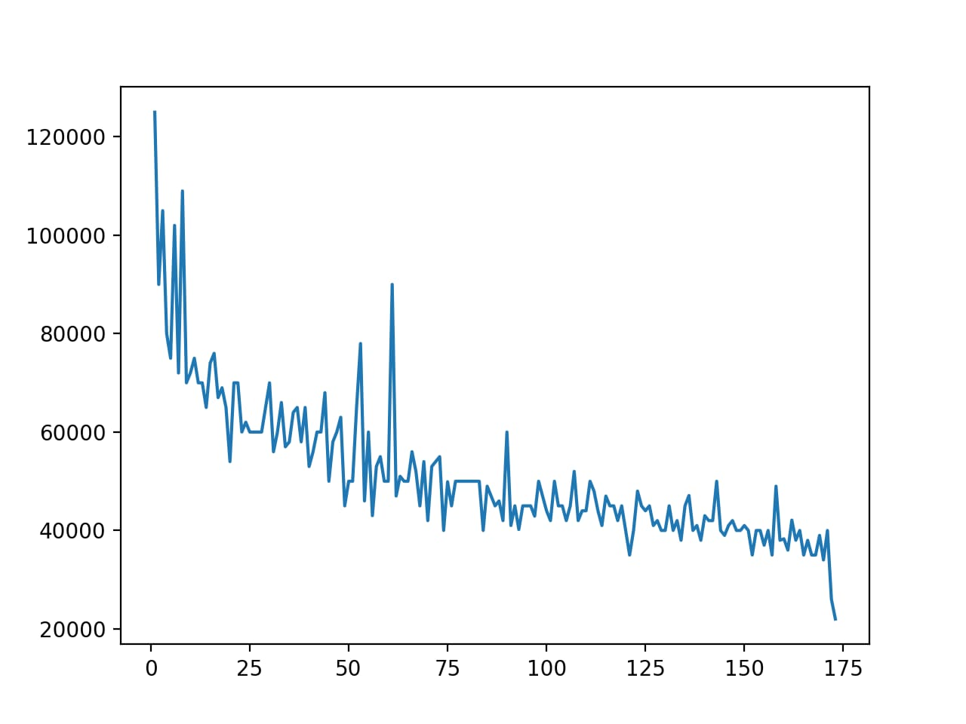

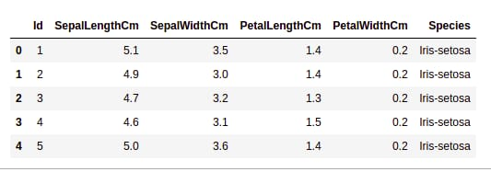

**CONCLUSION:**

In concluding a big data analysis, it's crucial to summarize the key findings and insights derived from the extensive data exploration and analysis process. The conclusion should Summarize the main discoveries, patterns, correlations, or trends uncovered during the analysis.Discuss the significance of the findings and their potential implications for the problem or domain under study.

Highlight how these insights can be applied or their relevance in decision-making. Acknowledge the limitations of the analysis, such as data quality issues, constraints in analysis techniques, or any other factors that might have impacted the results.

Suggest potential areas for further research or exploration, considering aspects that weren't covered or emerging trends that could be investigated in subsequent.

Offer recommendations based on the insights gained, proposing actions or strategies that could be implemented based on the analysis outcomes. Conclude by emphasizing the overall significance of the analysis in addressing the initial problem or objective and its relevance in the broader context.

A comprehensive conclusion should tie together the results of the analysis, providing a clear understanding of the implications and the value of the analysis in addressing the underlying questions or problems.